In Forest School the children have had fun identifying trees

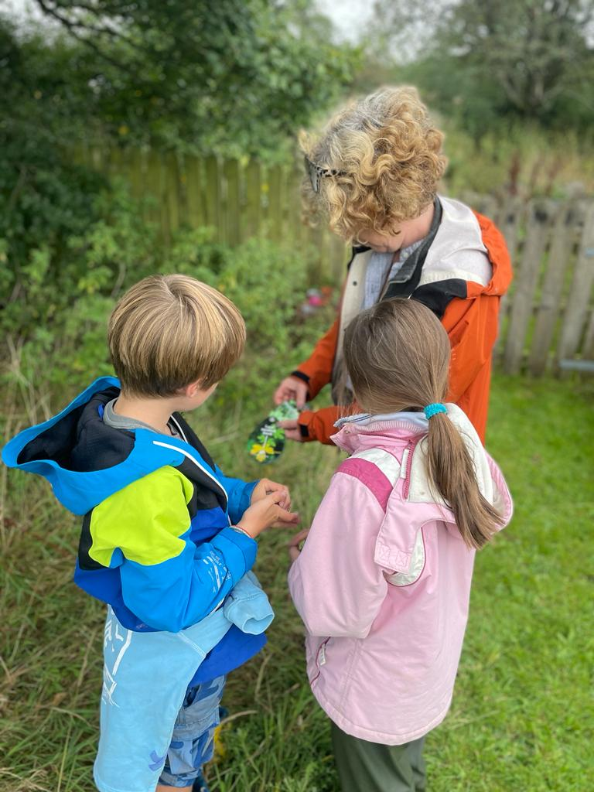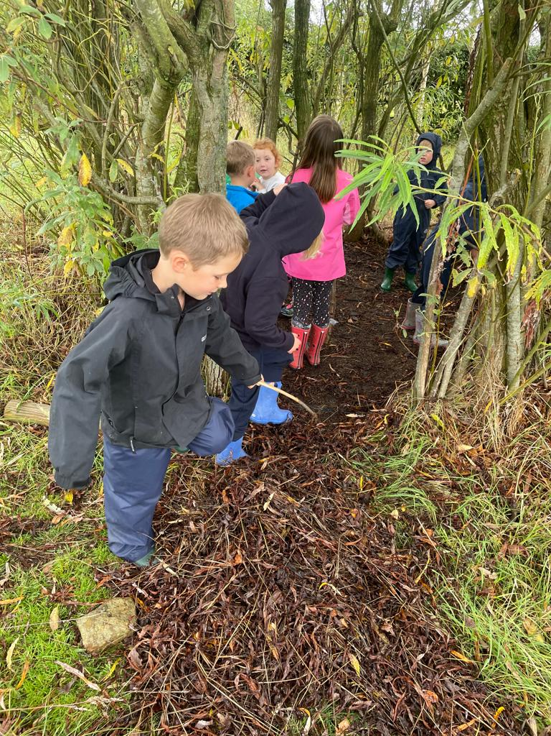

Our Week in KS1

This week in KS1 our learning has been linked to Katie Morag and the Isle of Coll.

 

In Art we have been looking at Tartan. Do you know if your family has a tartan? This is Mrs Taylor’s

‘ Taylor Tartan’

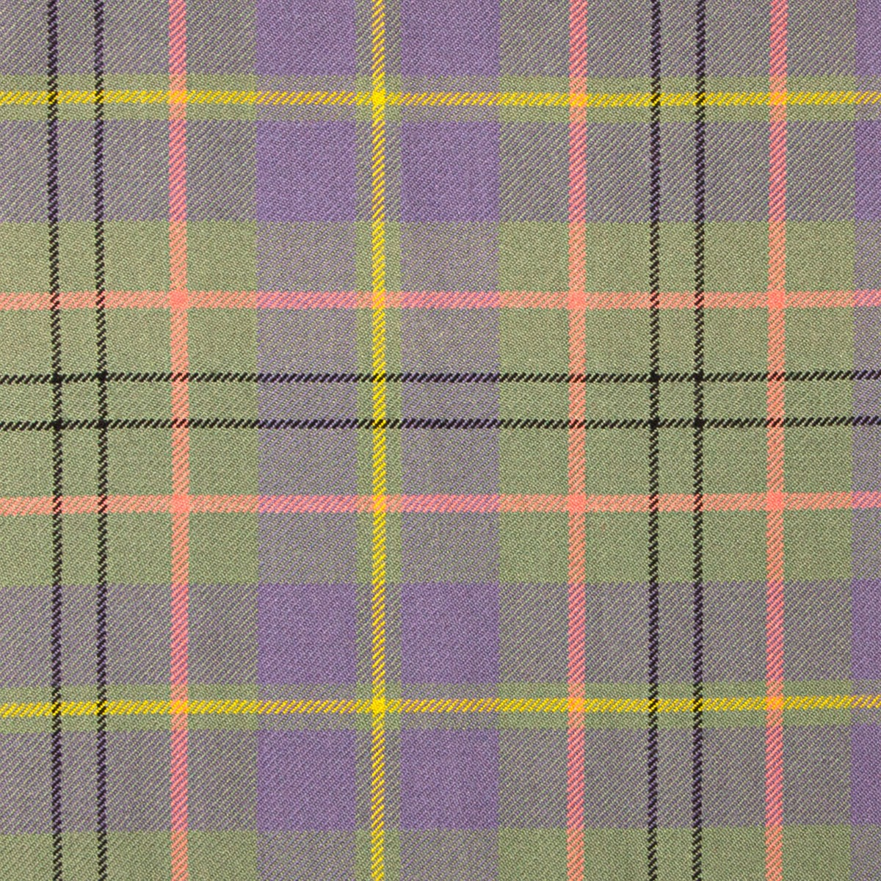

In English we have been making predictions and trying to work out how to help Katie with her dilemma!

The Children have been looking at differences and similarities about where Katie lives and where they live.