Next week we have an Art day with ‘Bev Art’ on Wednesday and the children will need their wellies as some of the Art will be taking place in the Forest School!

In Forest School the children loved harvesting apples. The children are going to make an apple crumble with the apples!

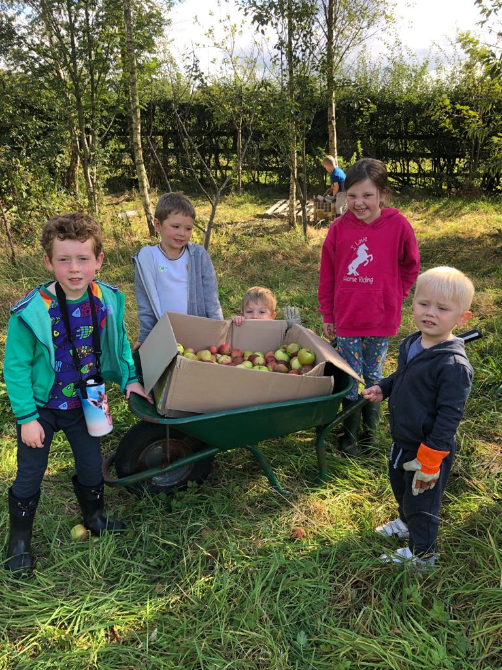

Our Week in KS1

This week in KS1 we have been celebrating Roald Dahls birthday.

The Children have been looking at lots of Roald Dahl books and we have focused on ‘The Enormous Crocodile’ and ‘Fantastic Mr Fox’

The children loved making their own fox and crocodile.

