All the children took part in the Tennis Taster sessions delivered by Ribble Valley Tennis Centre, there were some really skilled players.

In our English the children have been working hard on WOW adjectives for our story writing about Zog. Author Dan really captured the children’s imaginations and they thought of not only superb adjectives but amazing similes too !

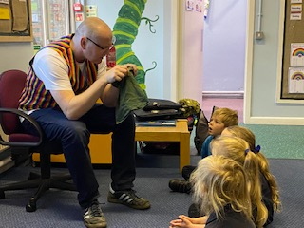

The Children had a wonderful fun morning on Wednesday meeting Dan Worsley. He is a very passionate author and told us one of his fabulous tales with such expression.

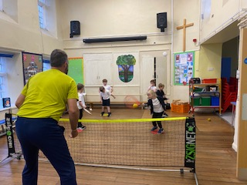

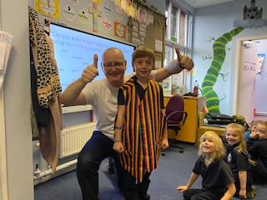

Our Week in KS1

This week we met our Patron for Reading

Author Dan Worsley