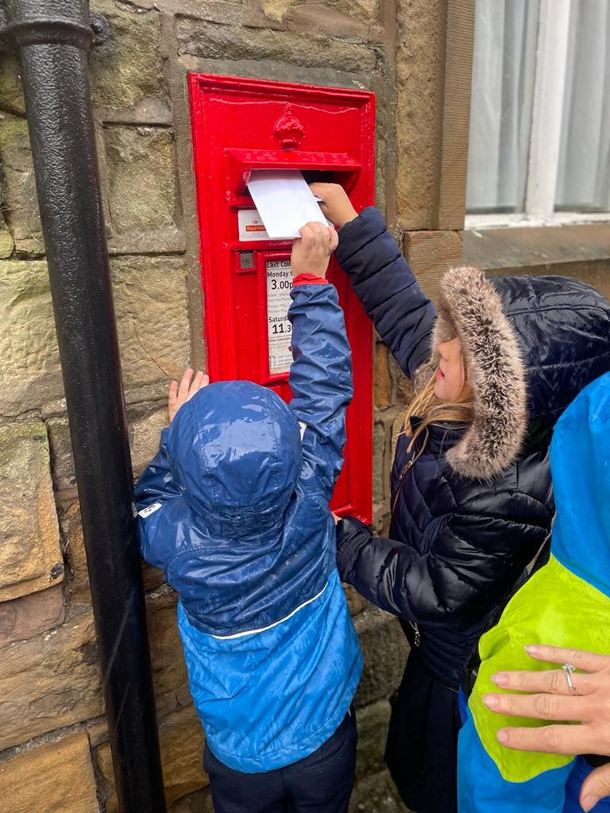

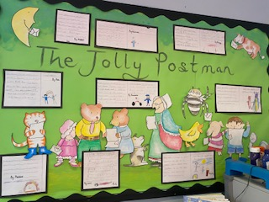

The Children had a wonderful afternoon with Emma and Harold the giraffe. Harold was super excited to be in School to sing Happy Birthday!

The children were so excited even in the rain to walk to the post box in Slaidburn and post a letter to their own home.

In our English the children have been working hard on their page for the Jolly Postman book. What super WOW adjectives you have all used!

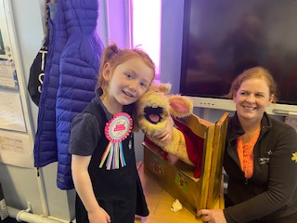

Our Week in KS1

This week we have had Life Education in School