The Children had a wonderful afternoon on Monday taking part in our sponsored wellie walk. The weather was lovely and we spotted lots of signs of Autumn.

In our English lessons the children have been looking at the Jolly Postman, they are really enjoying this book. They have even written and posted a letter home!

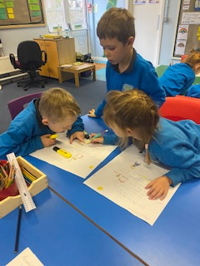

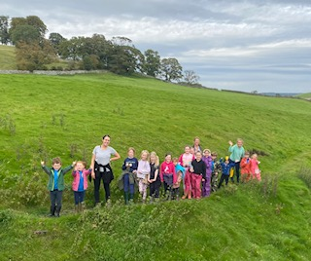

Our Week in KS1

This week we have been on our Wellie Walk!