Some of our Pre-School children have been practing developing their fine motor skills in the water tray this week which was enhanced with pom poms and tweezers to really get those little fingers working.

The Children have enjoyed playing different roles in the story of The 3 Billy Goats Gruff, with lots of recall from the story and I also over heard some fantastic repeated phrases.

In Forest School the children have had fun harvesting our home grown apples and we are looking forward to eating them in a campfire crumble soon!

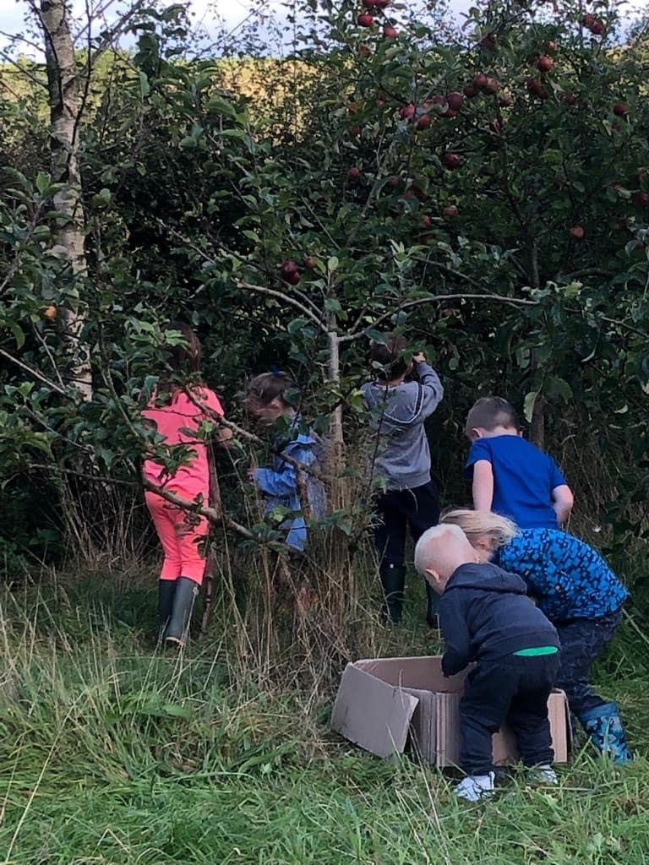

Our Week in EYFS.

This week in EYFS our learning has been linked to The 3 Billy Goats Gruff.

