In our Maths lessons in Year 1 and 2 we have been looking at measuring we have measured lots of objects using a metre stick and ruler inside and outside the classroom.

In our Geography lessons this week we went on a field trip into the village to look at the trim trail on the Green. We have been thinking about what improvements could be made to the play area.

All the children had a wonderful music session with Nick from ‘We Create Music’

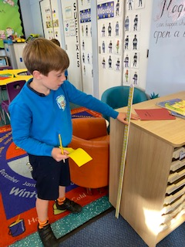

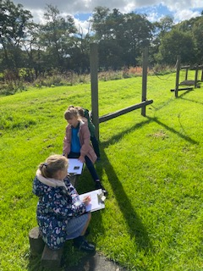

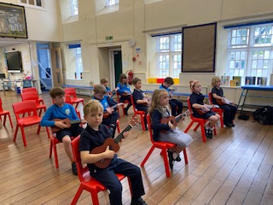

Our Week in KSI