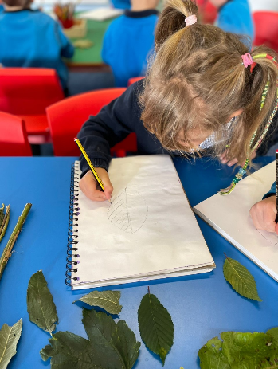

The children began the day working on observational drawings, they made their own paint brushes and even tried using charcoal for the first time attached to long canes. There was lots of concentration needed for this task! The children finished the day learning all about printing.

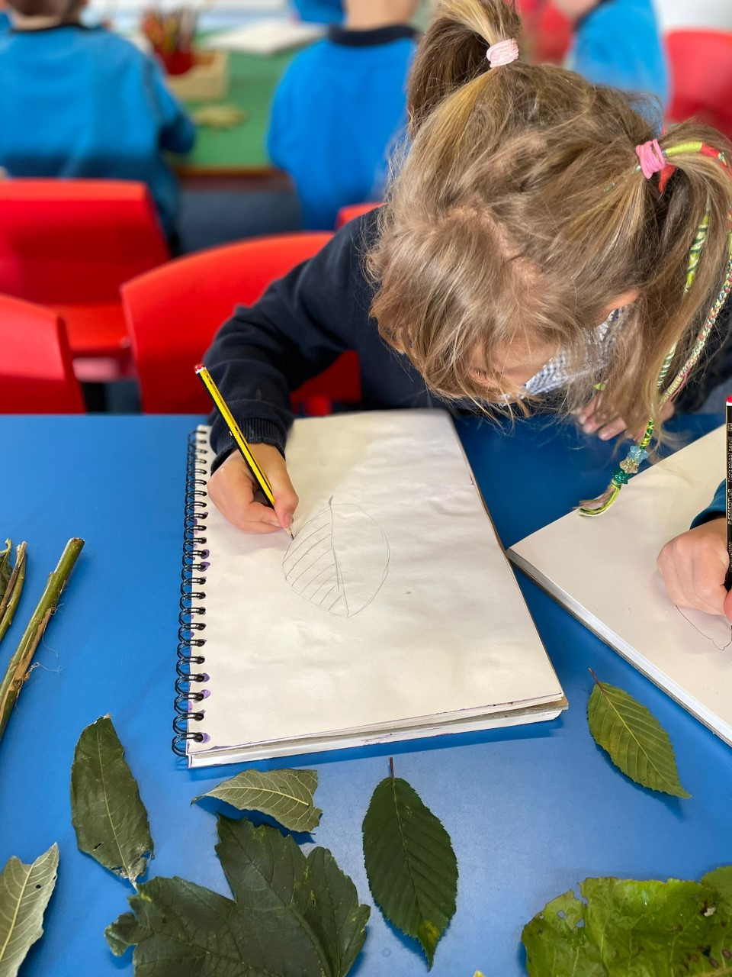

We have linked the Art day to our topic ‘ The place we live’ and the children have collected all natural materials in our Forest School to use in their art pieces.

Our Week in EYFS and KSI

This week we have had an ART day with a local artist from Atelier Art !

