In English we have been sequencing the story and creating our own pig houses and labelling them with the materials we used.

The children have enjoyed exploring our new maths area which has focused on recognising numbers to 10 and representing these with objects.

In Forest School the children have had fun identifying trees, exploring the fallen apples and have been involved in lots of imaginative play.

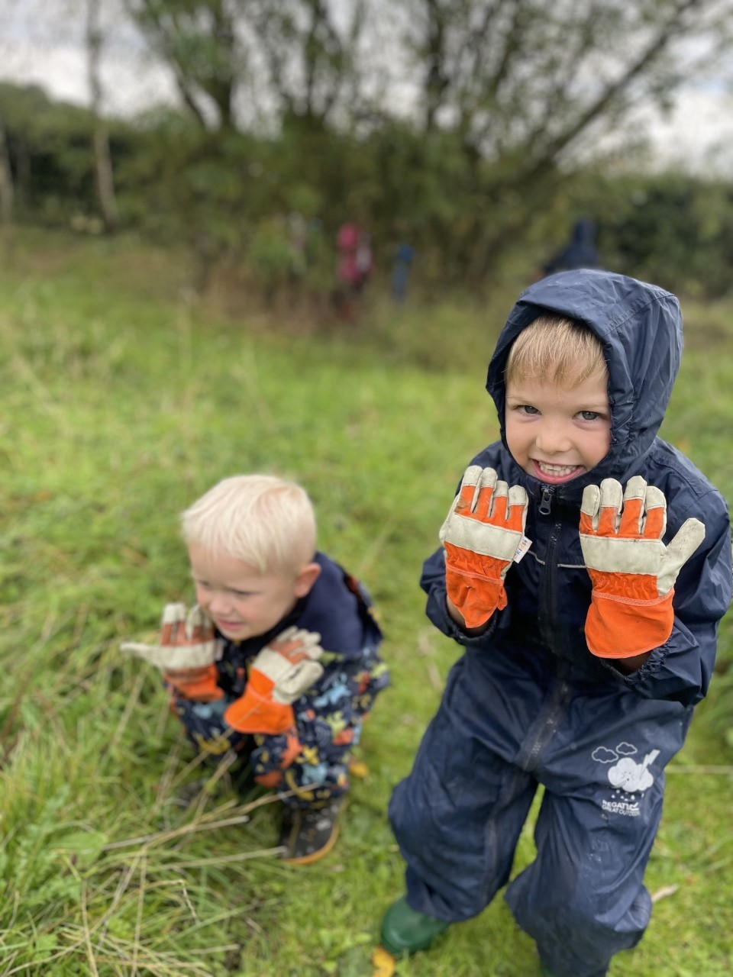

The Children have been learning about what makes a Traditional tale traditional and have been practicing their best huffs and puffs like the big bad wolf!

Our Week in EYFS.

This week in EYFS our learning has been linked to The 3 Little Pigs.

